**Longest Ordered test – Exe 2**

1. Login to Eclipse (used Java)
2. Create new Class Main
3. Copy-paste below code
4. String will be returned as “I am from Paris” while input string is {"am","I","France","from"}

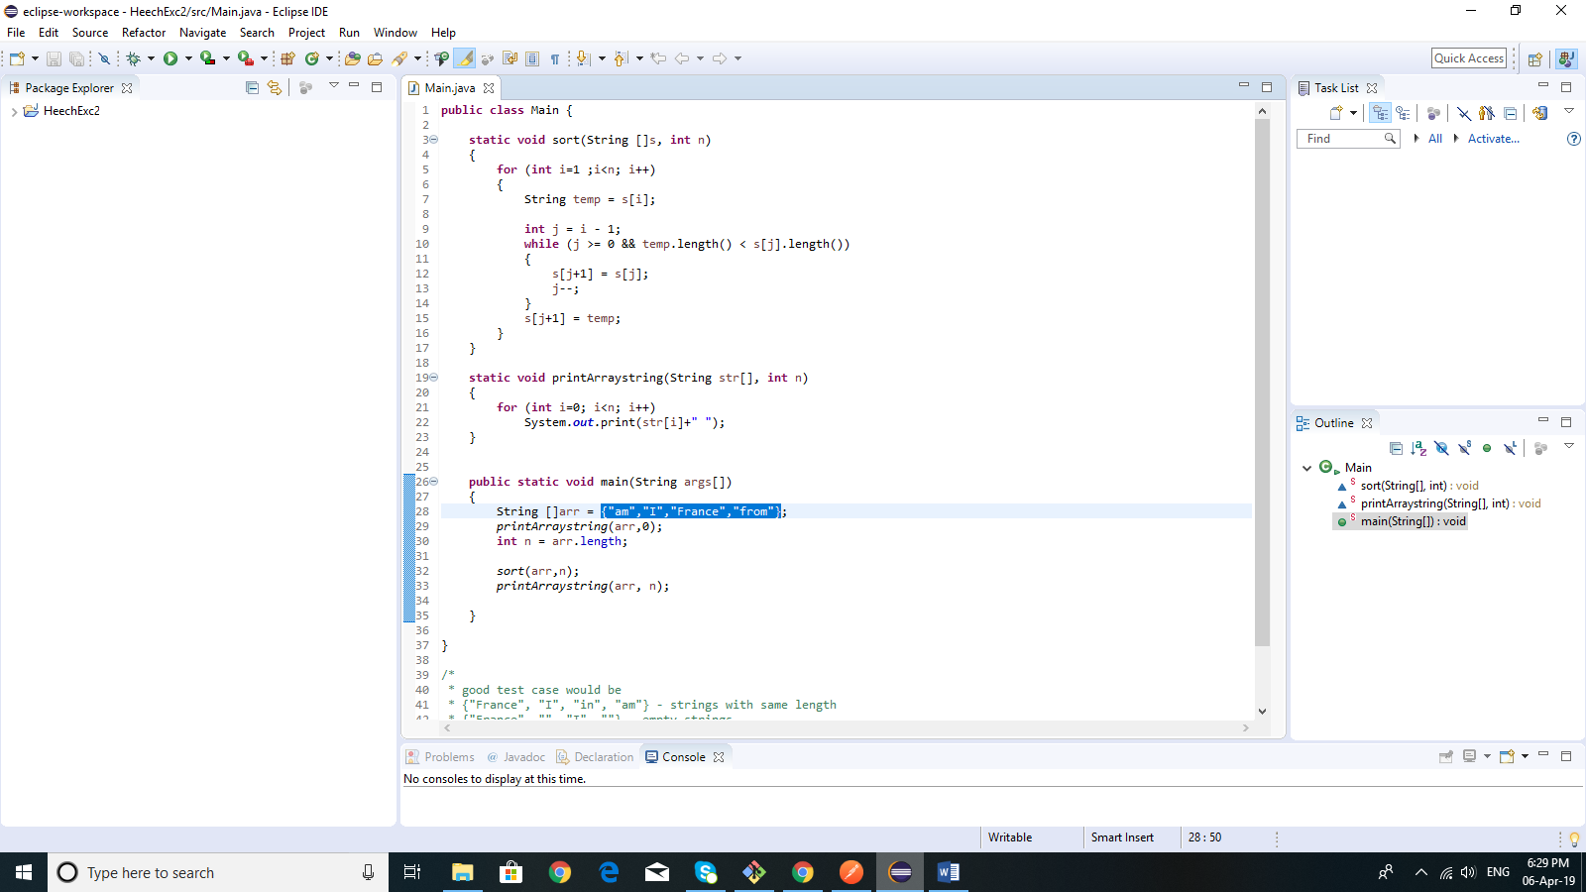

**public** **class** Main {

**static** **void** sort(String []s, **int** n)

{

**for** (**int** i=1 ;i<n; i++)

{

String temp = s[i];

**int** j = i - 1;

**while** (j >= 0 && temp.length() < s[j].length())

{

s[j+1] = s[j];

j--;

}

s[j+1] = temp;

}

}

**static** **void** printArraystring(String str[], **int** n)

{

**for** (**int** i=0; i<n; i++)

System.***out***.print(str[i]+" ");

}

**public** **static** **void** main(String args[])

{

String []arr = {"am","I","France","from"};

*printArraystring*(arr,0);

**int** n = arr.length;

*sort*(arr,n);

*printArraystring*(arr, n);

}

}

/*

* good test case would be

* {"France", "I", "in", "am"} - strings with same length

* {"France", "", "I", ""} - empty strings

* {"France"} - single string

*

*/